1. **What is API?**
2. **Java SE API**
3. **Java EE API**

**What is API?**

**1.What is an API?**

A. The class which is already developed and which is reused in our own class to perform some operation is called API. The API is single class/program.

In Simple terms , API is a reusable class. This class is in .class file.

The related API’s are packed as one package.

The packages are packed as one jar file.

Therefore, the programmer gets API’s in the form of **jar** files. The developer uses APIs in software development.

There are 3 types of APIs ..

1. Predefined API’s( given by language,Technologies and frameworks).
2. User-defined APIs( Created by Developer)
3. Third-party APIs( Given By Third party vendors).

Example:-

1. Language APIs

a.java.util and its subpackages.

b.java.lang and its subpackages.

if predefined API is not suffient to complete work then developer creates user defined API’s. He use them to complete work. Developer does not have time to create user-defined APIs. The API’s are purchased from third party vendor. These are used to complete work.

**JAVA SE API**

The java SE API is organized into 3 packages. The 3 packages are

a.java

b.javax

c.org

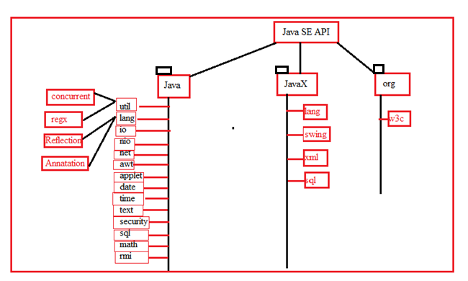

The Java package contains subpackages. The subpackage back have **base/basic** classes and subpackages.

The javaX package contains subpackages. The subpackage have advanced classes to develop the applications effectively.

Ex:-

The java.sql. package contains following classes which is used to develop the JDBC applications.

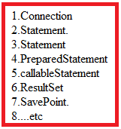

Problem:- Usually, Java application open connection . Through that connection application interact with db. After that Java application close that connection.

Suppose 10 java applications are creating own connection with same db. When connection is opening and closing frequently , that increase burden on DBMS.

To solve above problem, New concept was introduced. The concept is **connection pooling**. The **connection pooling related classes are in javax.sql package**.

**JAVA EE API**

The JavaEE API consists of only one package which is “**javax”**.

